

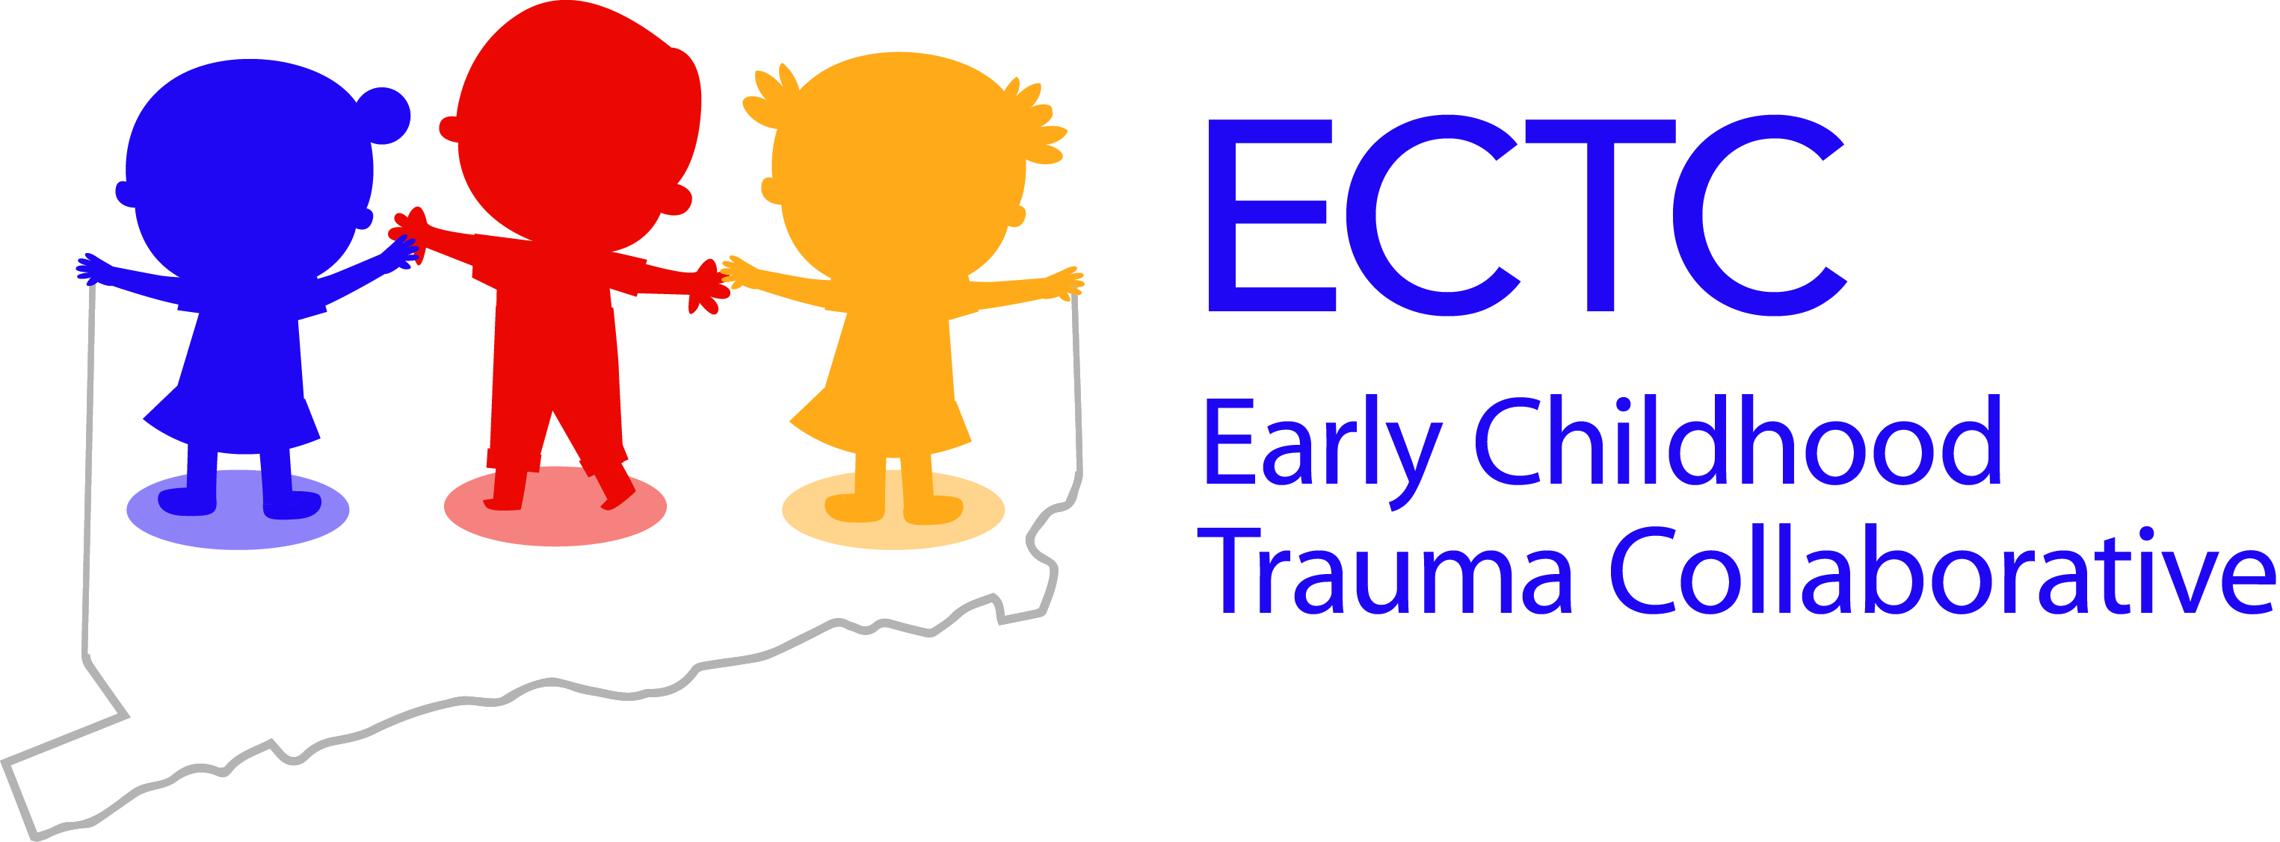

For Immediate Release
March 28, 2017
MEDIA ADVISORY
Early Childhood Trauma Collaborative Forum
Improving Care for Young Children (Birth through Age Six) Affected by Trauma

Farmington, CT – The Child Health and Development Institute of Connecticut (CHDI) will host a forum on early childhood trauma at the State Capitol on Thursday, March 30th. The forum will:
- Discuss the prevalence and effects of trauma on Connecticut's young children.
- Highlight evidence-based interventions for supporting young children exposed to trauma.
- Share the Early Childhood Trauma Collaborative initiative's five-year plan to expand trauma-informed services for children birth through age six in Connecticut.
The Early Childhood Trauma Collaborative is a five-year grant awarded to CHDI from the Substance Abuse and Mental Health Services Administration (SAMHSA) as part of the National Child Traumatic Stress Network to expand trauma-focused services to young children in Connecticut. The initiative aims to improve knowledge about childhood trauma among Connecticut’s early childhood workforce and increase access to trauma-focused evidence-based practices for children under seven and their families.
WHAT: Early Childhood Trauma Collaborative Forum

WHEN: Thursday, March 30, 2017
9:15 am – 11:00 am (continental breakfast/registration begins at 8:45 am)

WHERE: State Capitol, Room 310, Hartford, CT

FORMAT: A brief overview of early childhood trauma and the Early Childhood Trauma Collaborative will be followed by a panel discussion and audience questions.
Speakers:
Governor Dannel Malloy
Lieutenant Governor Nancy Wyman
Judith Meyers, President & CEO, CHDI
Jason Lang, Director of Dissemination & Implementation, CHDI
Panelists:
Alice Forrester, CEO, Clifford Beers Clinic
Linda Goodman, Acting Commissioner, Office of Early Childhood
Melissa Mendez, Board President, Connecticut Association for Infant Mental Health
Kristina Stevens, Children and Families Administrator, Department of Children and Families
Family Perspective

MEDIA: Media interested in attending should contact Julie Tacinelli at tacinelli@uchc.edu or 860-679-1534. Learn more at www.chdi.org/ectc.

###

