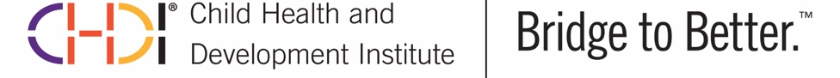
FOR IMMEDIATE RELEASE
March 28, 2022

CHDI Awarded “Best Places to Work in Connecticut” by the Hartford Business Journal & New Haven Biz

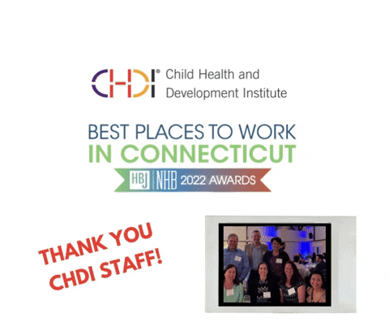
FARMINGTON, CT - The Child Health and Development Institute (CHDI) was named one of the “Best Places to Work” in Connecticut by The Hartford Business Journal and New Haven Biz. CHDI ranked first among non-profits and eighth among small/medium-sized employers for the 2022 award. The award honors organizations who rank highest in employee satisfaction as determined by a survey administered nationally by the Best Companies Group.

"We are proud to be recognized as one of the top workplaces in the state," said President and CEO Jeffrey Vanderploeg. "It is a testament to our incredible staff, who are passionate about their work and committed to improving behavioral health care for children, youth, and families."

CHDI is an independent not-for-profit organization with 31 employees based in Farmington, Connecticut. CHDI provides a bridge to better behavioral health and well-being for children, youth, and families by advancing system, practice, and policy solutions that result in equitable and optimal outcomes in Connecticut and beyond.

CHDI received high marks for the organization's positive culture, healthy work-life balance, flexibility, generous remote options, competitive benefits package, and engaged staff. CHDI attracts and hires a multi-disciplinary team of people who are passionate, self-motivated, and highly effective at what they do. CHDI's culture reflects the organization’s values of collaboration, accountability, respect, equitable action, and anti-racism. A staff-led "Sunshine Committee" established during the pandemic supports employees during hardship, celebrates employees’ successes, and fosters social connections.

The 37 winners of the 2022 New Haven Biz and Hartford Business Journal's Best Places to Work in Connecticut Award were recognized at a ceremony on March 24 and will be featured in the Hartford Business Journal's March 28th issue and New Haven Biz’s April Issue. Learn more about the award and view CHDI's profile.

CHDI is looking to expand our team. If you are looking for a rewarding career, view our open positions at www.chdi.org/jobs. Follow us on Twitter, Facebook, and LinkedIn to stay up-to-date on all the latest job postings and news from CHDI.

###

