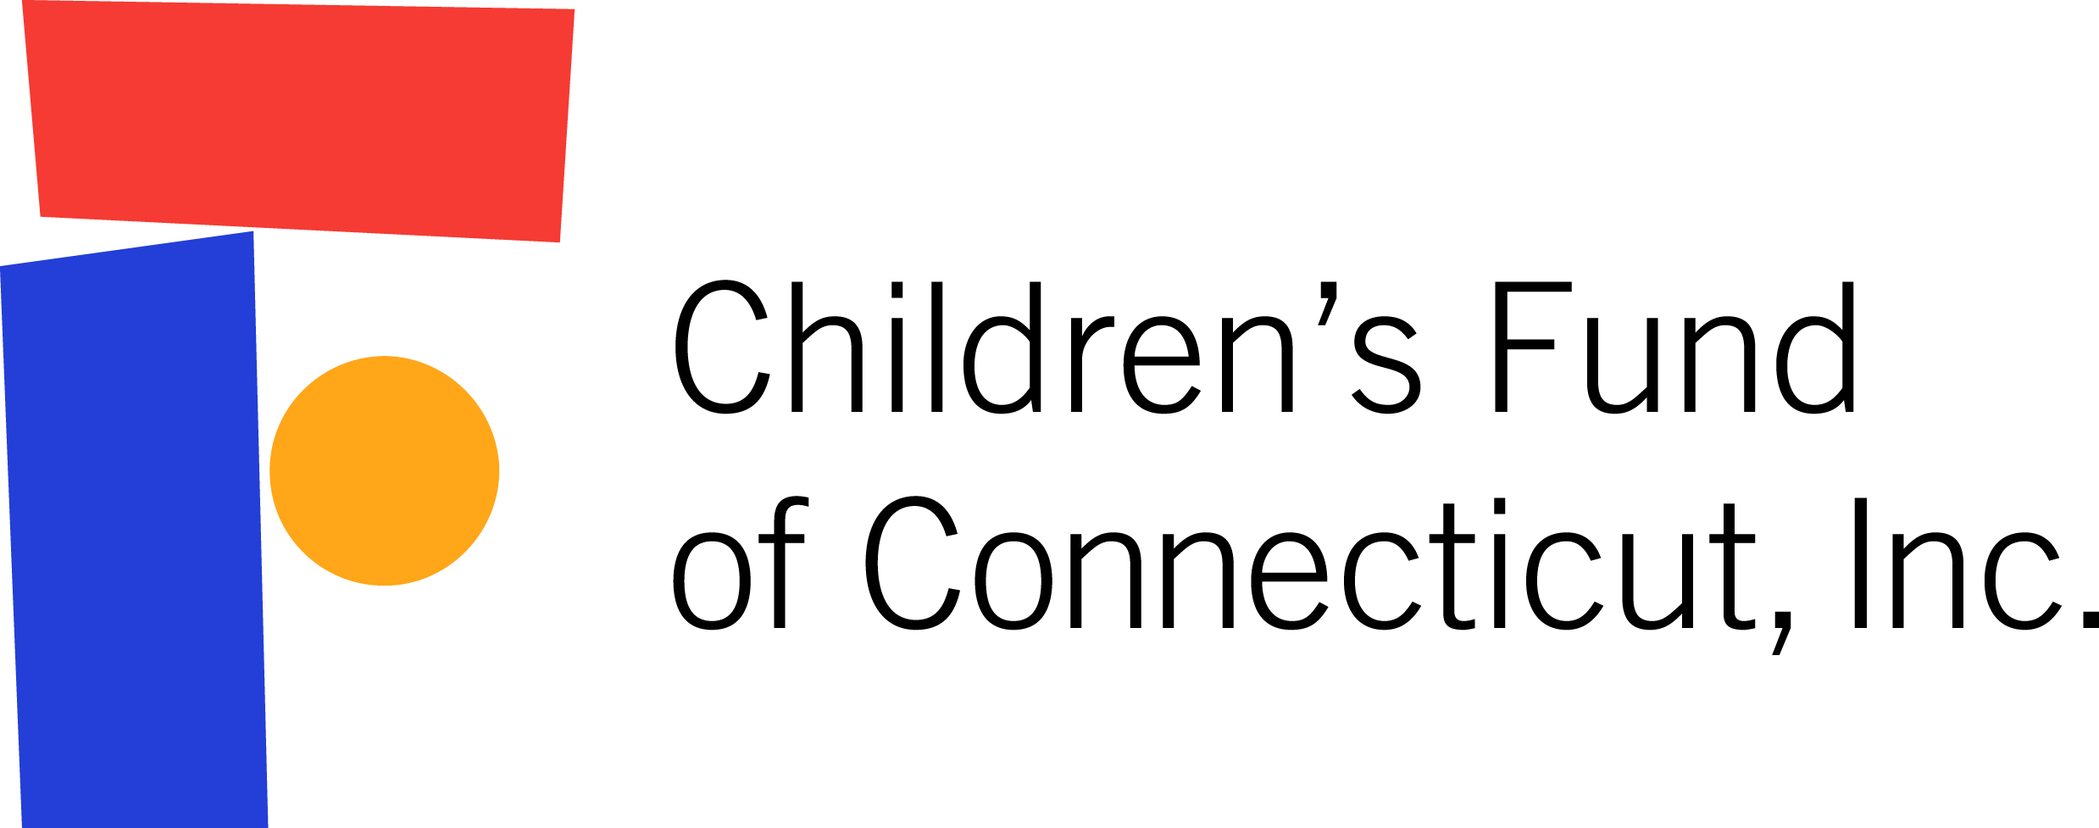

FOR IMMEDIATE RELEASE
June 19, 2017

After 18 Years of Leadership, CHDI Founding Chief Executive Judith Meyers Announces Plans to Step Down

Meyers to leave CHDI September 30, 2017, but will remain President & CEO of the Children’s Fund of Connecticut through September 2018

Board will transition leadership to CHDI’s Jeffrey Vanderploeg

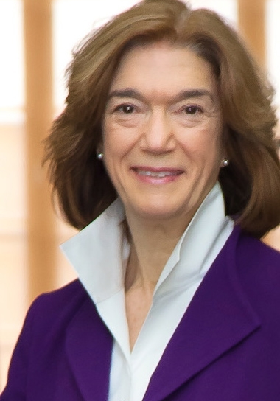
Farmington, CT – Judith Meyers, who for nearly two decades has been a leader improving children’s health and well-being in Connecticut, announced plans to step down as President and CEO of the Child Health and Development Institute of Connecticut (CHDI) as of September 30, 2017. At its June 15th meeting, CHDI’s Board selected Jeffrey Vanderploeg, CHDI’s Vice President for Mental Health Initiatives to become the next President and CEO effective October 1, 2017. Meyers will continue to serve as President and CEO of the Children’s Fund of Connecticut, CHDI’s parent organization and supporting organization of Connecticut Children’s Medical Center, through September 30, 2018 and continue her work on early childhood as a senior fellow, both on a part-time basis.

“By bridging the worlds of research, policy, and practice, CHDI and the Children’s Fund have helped improve children’s health and mental health care in Connecticut,” said Meyers. “However we have not done this work alone. It has been a true privilege for me to work alongside our talented staff, our wonderfully supportive board, and our long list of dedicated partners to make this difference in the lives of children and families.”

Meyers has led CHDI since it began operations as a non-profit dedicated to improving children’s health and well-being in 1999. In 2002, CHDI became a subsidiary of the Children’s Fund of Connecticut, a public charitable foundation founded in 1992 to champion sustainable improvements in children's health and mental health through innovative grant making. The Board hired Meyers in 1999 as Executive Director and the first and sole employee of CHDI. She became President and CEO of both CHDI and the Children’s Fund of Connecticut in 2002 and was charged with building the two organizations into what they are today.

Under her tenure, CHDI grew from one to 30 employees, more than quadrupled its annual operating budget, and forged partnerships to collaborate with multiple organizations; while the Children’s Fund awarded over $18 million in grants (2002-2016) to support new innovations and the work of CHDI. Together, this work has resulted in meaningful changes to our State’s systems, policies and practices so they work better for Connecticut’s children and families, including:
- Developing and supporting plans that have helped to redesign and improve children’s health, mental health and early childhood systems in the state.
- Advancing innovations in child health care services such as care coordination, mid-level developmental assessment, maternal depression screening, developmental surveillance, and co-management, resulting in earlier intervention for children with concerns and better coordinated care.
- Driving mental health system innovations that have dramatically increased families’ access to quality trauma-informed mental health care and helped both early childhood and K-12 education systems address mental health challenges, including: early childhood mental health consultation, the School-Based Diversion Initiative and the dissemination of multiple trauma-informed evidence-based mental health treatments statewide.
“Judith has done a truly amazing job positioning CHDI and the Children’s Fund as a knowledge-driven change-maker for children’s health and mental health in Connecticut,” said Margaret Grey, former Dean of the Yale School of Nursing and current CHDI Board Chair. “She has helped build stronger and more effective health and mental health systems that result in better outcomes for all children in Connecticut, especially the underserved.”

Among her many accomplishments, Meyers was honored with the first Jane Bournes Award for Excellence from the CT Association for Infant Mental Health in 2007 and the Connecticut Voices for Children 2016 Priscilla Canny Research Award for her leadership in strengthening the connections between research, policy and practice. She also was recently awarded the 2017 Distinguished Contributions to Practice in Community Psychology from the Society for Community Research and Action (a division of the American Psychological Association) for her career practicing as a community psychologist at the highest levels in foundations, government and nonprofits in order to improve the lives of children. She currently serves as Chair of the Board of the Connecticut Council for Philanthropy.

“Although much has improved in health and mental health care for children in Connecticut since I started, we know that our work is not done,” said Meyers. “I can’t think of a better person to take CHDI to the next level in leading this work than Jeff Vanderploeg, an exceptional thinker, leader, and collaborator. Together with our many partners and dedicated staff, Jeff will ensure CHDI continues to push for meaningful system, policy and practice change.“

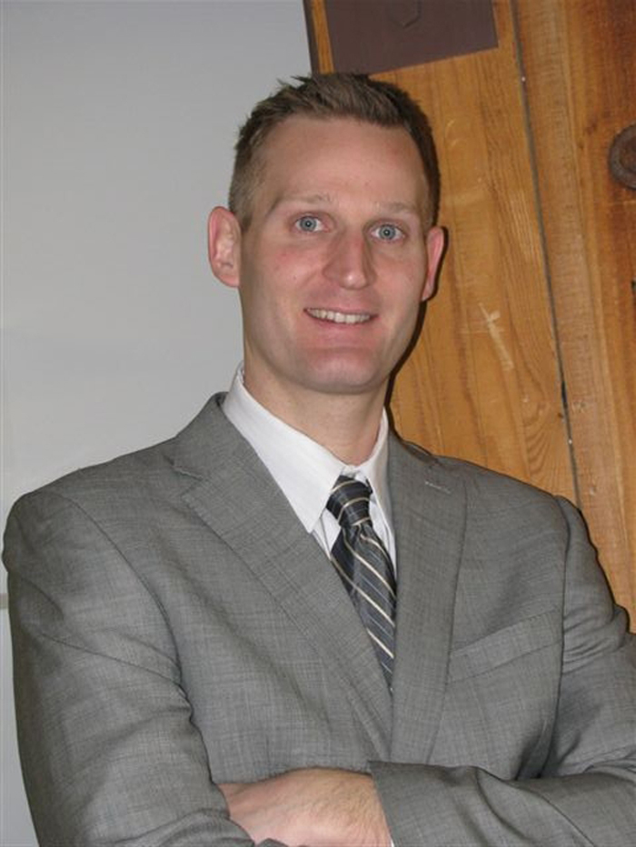
Jeffrey Vanderploeg joined CHDI in 2009. As Vice President since 2014, he oversees CHDI’s mental health initiatives and was instrumental in developing the statewide Children’s Behavioral Health Plan in partnership with the Connecticut Department of Children and Families. He is a member of several statewide committees and councils in children’s behavioral health policy, including co-chairing the Quality, Access and Policy Subcommittee of the CT Behavioral Health Partnership.
Vanderploeg received a Ph.D. in clinical psychology from Bowling Green State University and completed predoctoral and postdoctoral training at Yale University School of Medicine. In 2015 he participated in the Capitol Region Leadership Development Roundtable, a selective non-profit leadership development program.

About CHDI
The Child Health and Development Institute of Connecticut, a subsidiary of the Children’s Fund of Connecticut, is a non-profit organization established to improve the health and well-being of children by advancing system, policy, and practice changes. CHDI helps children reach their full potential by building stronger health, mental health, and early care systems that provide a sturdy foundation so children can thrive. Learn more at www.chdi.org.

About the Children’s Fund of CT
The Children’s Fund of Connecticut, a public charitable organization and supporting organization of Connecticut Children’s Medical Center, is dedicated to improving the quality of children’s lives by building stronger health systems through its grantmaking and support for its subsidiary, CHDI. Learn more at www.childrensfundofct.org.

For media questions, contact Julie Tacinelli at tacinelli@uchc.edu or 860-679-1534.

###

