For Immediate Release
October 31, 2013

Report Examines Role of Developmental Screening in Ensuring School Readiness and Provides Recommendations for Connecticut

Hartford – Today the Connecticut Early Childhood Education Cabinet released a report in collaboration with the Child Health and Development Institute of Connecticut (CHDI) and the Office of Early Childhood. The report titled “The Earlier the Better: Developmental Screening for Connecticut’s Young Children,” was prepared by CHDI and presented at this morning’s Cabinet meeting. The Cabinet commissioned the report to inform the state’s work for ensuring school readiness for Connecticut’s children. According to the report, national estimates show that about half of the children who begin kindergarten are not ready for school due to health, developmental and behavioral concerns.

”Early detection of any roadblocks to success is key to ensuring that children are on the right trajectory to enter kindergarten ready to learn and reach their full potential,” said Leah Grenier, Chair of Connecticut’s Early Childhood Education Cabinet. “This report will be a great resource to inform the Office of Early Childhood and the State of Connecticut in their efforts to close the achievement gap.”

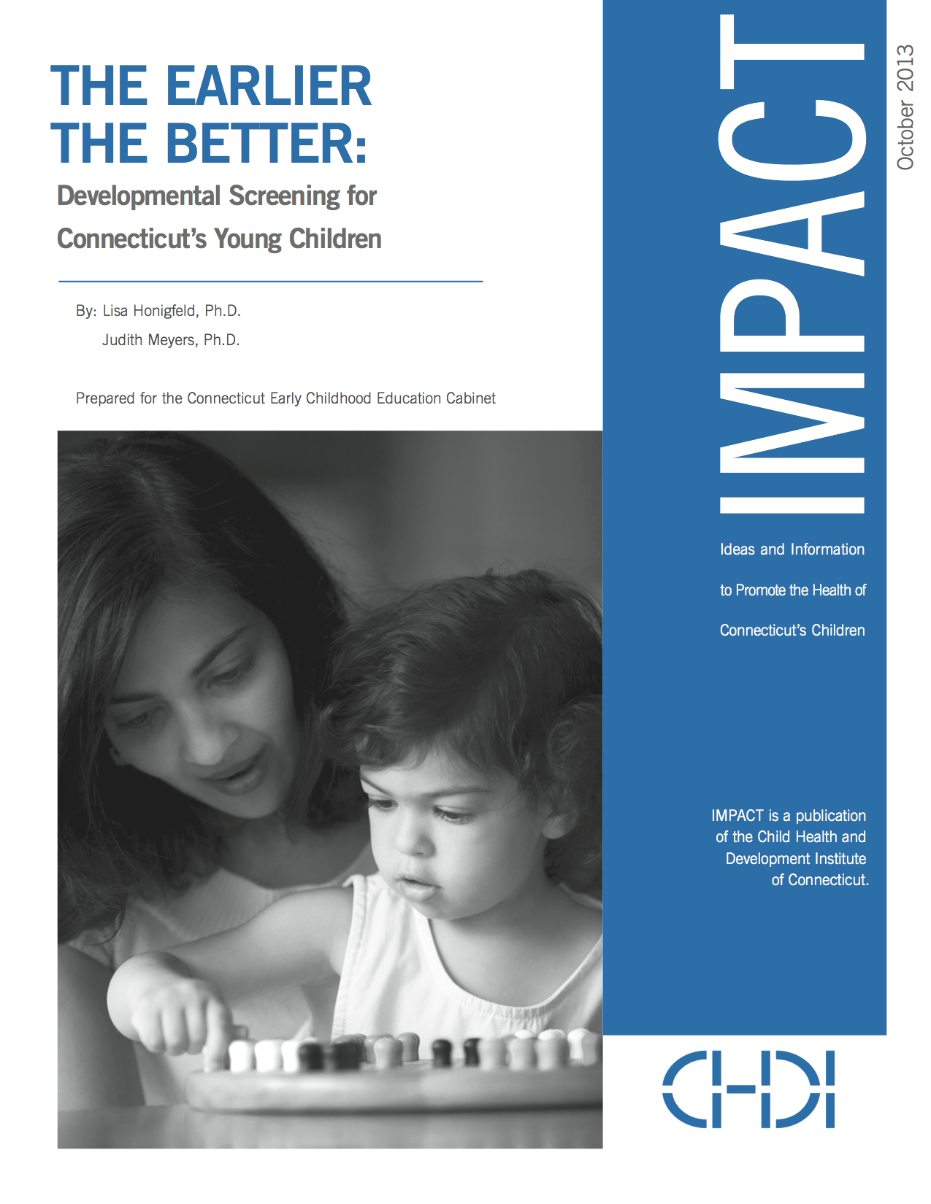
“The Earlier the Better: Developmental Screening for Connecticut’s Young Children,” report highlights the role of screening in a comprehensive approach to school readiness and includes:

- Current research on the value of early detection of developmental & socio-emotional delays
- An examination of screening as a strategy for early detection
- An outline of valid available screening tools and their implementation across Connecticut
- Recommendations for how Connecticut can build a robust system of early identification of children with developmental and mental health needs

“Connecticut is in an excellent position to advance strategies that will assure that all children have appropriate developmental screens and that we have the systems in place to assure that those children identified as needing further assessment, services and supports, receive them,” said Myra Jones-Taylor, Executive Director of the newly formed Office of Early Childhood.

Connecticut was recently awarded a federal Early Childhood Comprehensive Systems grant, which will focus on the expansion of developmental screening and integrating it in and across early care and education settings, early intervention programs, home visiting and pediatric services. The Office of Early Childhood has also endorsed universal and coordinated developmental screening that is integrated with assessment and intervention services in its recent application to the US Department of Education under the Race to the Top - Early Learning Challenge competition for grant funding to improve school readiness.

“The state has shown a strong commitment to addressing children’s healthy development as part of their overall work to improve school readiness,” said Judith Meyers, President and CEO of CHDI and co-author of the report (along with Lisa Honigfeld, CHDI’s Vice President for Health Initiatives). “We are pleased to have this opportunity to contribute knowledge and expertise to inform the state’s efforts to develop a coordinated system of early detection and connection to services.”

The Earlier the Better: Developmental Screening for Connecticut’s Young Children IMPACT can be downloaded at www.chdi.org.

For information on the Connecticut Early Childhood Education Cabinet, please contact Andrea Brinnel at Andrea.Brinnel@ct.gov or 860-713-6771. For further information about the Child Health and Development Institute, please visit www.chdi.org or contact Julie Tacinelli at tacinelli@uchc.edu or 860-679-1519.
###

