Reduction of Emergency Department Use for Child/Adolescent Behavioral Health
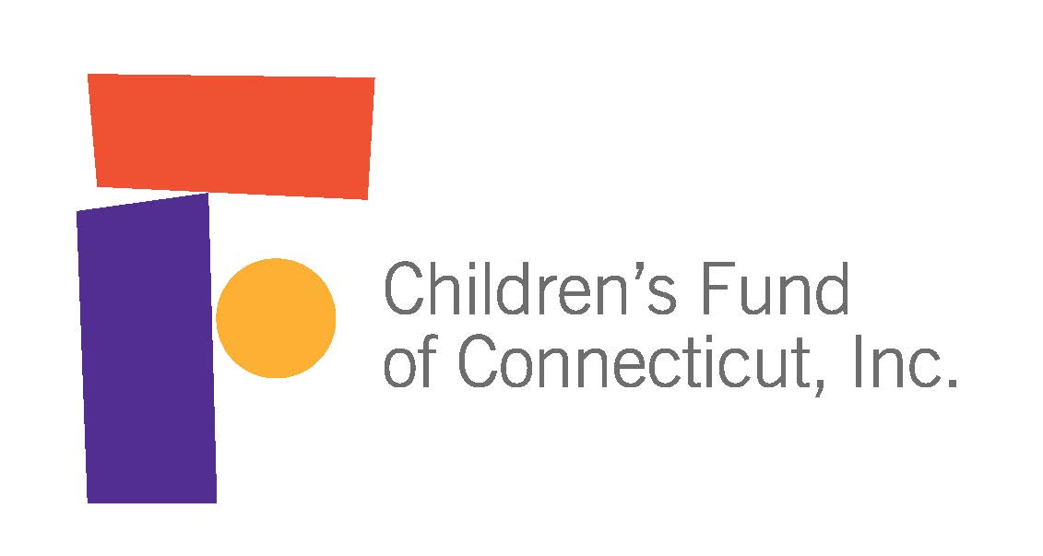
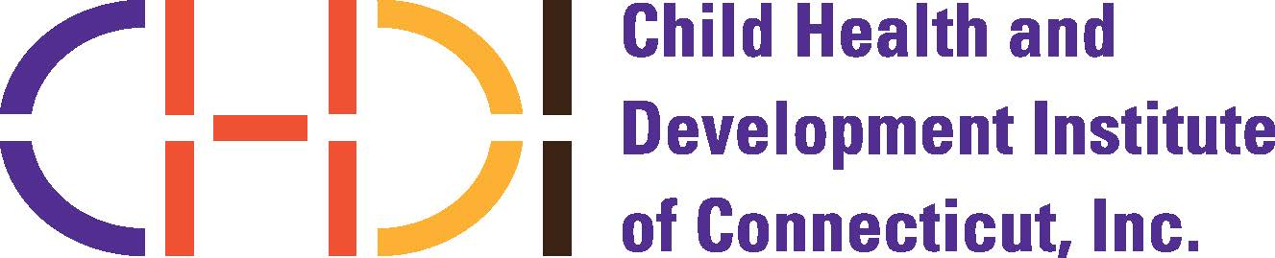
Request for Letters of Intent (LOI)
Release Date: May 1, 2019 LOI due by: June 10, 2019

Background
The Child Health and Development Institute of Connecticut (CHDI), with funding from the Children’s Fund of Connecticut, is pleased to offer a new grant opportunity aimed at preventing unnecessary referral of, or improving emergency departments’ (EDs) response to, youth (including children and adolescents) with behavioral health conditions. Recent data show a national trend of increased ED use among youth with behavioral health conditions, including a 20% increase from 2014 to 2016 among youth enrolled in Medicaid in Connecticut (Hoge, Vanderploeg, Plant, & Graham, 2018).

The purpose of this Request for Proposals (RFP) is to test an innovative, scalable, collaborative, and evidence-informed approach to improve the delivery of behavioral health services, within hospital EDs and in partnership with the community, to manage and treat children and adolescents with behavioral health conditions. This RFP was developed based on recommendations from a statewide workgroup and report that applicants are encouraged to read before developing an application (Hoge et al., 2018).

This RFP is an opportunity for community based mental health agencies, schools, hospitals, and/or other community-based organizations to connect youth and their parents/caregivers to a broader array of services which promote community-based alternatives to ED usage and/or improve the quality of ED care for this population. Project outcomes are expected to inform and advance efforts by policymakers, practitioners, program staff and advocates committed to serving youth in the most appropriate settings and reducing unnecessary or inappropriate ED usage for youth with behavioral health conditions.

Target Population
The target population is youth with behavioral health conditions who are at risk of being transported to the ED, or who have been brought to the ED, and their parents/caregivers.

Grant Focus Area
Proposals must address at least one of the following focus areas identified as recommendations in the ED report (Hoge et al., 2018):
- Collect, analyze, and report data that will inform a better understanding of the characteristics and needs of youth presenting to EDs with behavioral health conditions, strategies for diverting low-risk youth from ED settings, and/or strategies for improving the delivery of behavioral health services within high volume ED settings serving children, youth, and families.
- Develop and/or pilot a screening, triage, or acuity assessment measure in order to more efficiently triage youth presenting in the ED for behavioral health concerns.
Priority will be given to proposals that address one or both of the focus areas above. However, proposals describing other innovative approaches will also be considered, as long as they clearly address one or more findings and recommendations of the report.

Project Criteria
Proposals should address as many of the following project criteria as possible:
- Identify a clear connection between the project activities and the overall goal of preventing unnecessary referral of, or improving ED response to, youth with behavioral health conditions
- Incorporate research and use of best practices, evidence-based practices, or promising practices into the project activities and workplan
- Enhance collaboration and communication across programs, services, or systems
- Identify clear, measurable project outcomes and a plan for evaluating the extent to which the program met these outcomes
- Demonstrate attention to promoting health equity and reducing disparities according to race, ethnicity, socio-economic status, gender, sexual orientation, religion, or other factors
- Demonstrate consideration for the role of caregivers/parents and other informal supports in improving services for youth at risk of or referred to the ED
- Potential for informing further development of, or use as, a scalable model that could be replicated in other locations

Total Awards
CHDI expects to award two grants of $25,000 each. The project period is October 1, 2019- September 30, 2020. Applicants are encouraged to secure additional funding or in-kind services from other sources if needed to finance their proposed project.

Eligibility
This RFP is open to hospitals, community-based mental health agencies, and/or school districts in Connecticut. The Children’s Fund of Connecticut does not fund individuals, private foundations, or federal agencies. The Children’s Fund does not fund building projects, endowments, lobbying, or projects that do not benefit primary or preventive pediatric or mental health care in Connecticut.

Use of Grant Funds
Grant funds may be used for project staff salaries, consultant fees, parent stipends, program fees, supplies, project-related travel, and other direct project expenses including a limited amount of equipment essential to the project. Grant funds may be used to purchase services from community partners. Indirect costs are limited to 15% of the direct costs.

Grantee Expectations
Applicants selected for this RFP will be expected to identify a person within the grantee organization to lead this work, complete an interim report at 6 months, and complete a final report at the conclusion of the grant period.

Evaluation Criteria
Full proposals will be invited based on LOIs and evaluated according to the following criteria:
- Qualifications and experience of the organization and project personnel, and understanding of how the project will fit into Connecticut’s systems
- Extent to which the project addresses the Grant Focus Area and Project Criteria above
- Extent to which the project addresses the target population above
- Likelihood of success for the program goals and of the grant to demonstrate successful implementation and inform future improvements for this population
- Appropriateness of budget and project timeline

Key Dates
Request for LOI released | May 1, 2019
LOI due by 5pm | June 10, 2019
Successful LOI submissions invited to submit full proposal | June 28, 2019 - Full proposals will be aligned with information requested in the LOI and limited to 5 pages.
Full proposals due (by invitation only) | July 31, 2019
Notification of awards | August 31,2019 - Grants distributed following execution of fully signed Letter of Agreement
Project start date | October 1, 2019

Letters of Intent (LOI)
Please submit your LOI to Yecenia Casiano at casiano@uchc.edu with the following information:
- Name of applicant/agency
- Name, title, email of contact person for this LOI
- Amount requested from the Children’s Fund of CT
- Key project partners (letters of support not required with submission of the LOI)
- Brief description of the project’s proposed activities and how it will address the Grant Focus Area and Project Criteria.

LOIs should be no longer than 2 pages (single-spaced, 1” margins, 11 or 12 pt. font).

Please contact Yecenia Casiano, Senior Project Coordinator, at casiano@uchc.edu with questions about this RFP.

Hoge, M.A., Vanderploeg, J., Plant, R., & Graham, S. (2018). Emergency Department Use by Connecticut Children and Youth with Behavioral Health Conditions: Improving Care and Promoting Alternatives. Farmington, CT: Child Health and Development Institute. Available at: https://www.chdi.org/index.php/publications/reports/other/emergency-department-use-connecticut-children-and-youth-behavioral-health-conditions).

